Project Design Phase
Solution Architecture

Date | 14 July 2026
Team ID
Project Name | UCab Premium - MERN Cab Booking System
Maximum Marks | 4 Marks

Solution Architecture:
Solution architecture is a complex process – with many sub-processes – that bridges the gap between business problems and technology solutions. Its goals are to:
- Find the best tech solution to solve existing business problems.
- Describe the structure, characteristics, behavior, and other aspects of the software to project stakeholders.
- Define features, development phases, and solution requirements.
- Provide specifications according to which the solution is defined, managed, and delivered.

Example - Solution Architecture Diagram:


Figure 1: Architecture and data flow of the voice patient diary sample application
Reference: https://aws.amazon.com/blogs/industries/voice-applications-in-clinical-research-powered-by-ai-on-aws-part-1-architecture-and-design-considerations/

Solution Architecture Diagram – UCab Premium
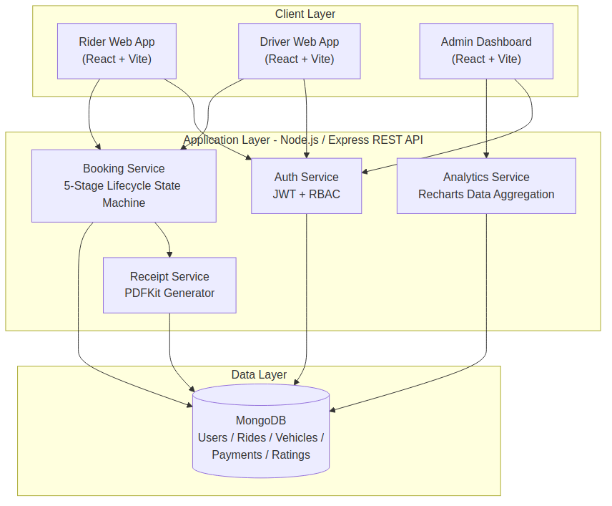
Figure 1: Three-tier MERN architecture of UCab Premium showing the Client, Application, and Data layers.
Architecture Component Description
Component | Description
Client Layer | 3 role-based React (Vite) SPAs (Rider, Driver, Admin) across 23 total pages consuming REST APIs over HTTPS.
Auth Service | Issues and verifies JWTs; enforces role-based access control (RBAC) for Rider / Driver / Admin routes.
Booking Service | Drives the five-stage booking lifecycle state machine (Requested -> Accepted -> In-Progress -> Completed -> Rated) across 35 REST endpoints in 5 resource groups.
Analytics Service | Aggregates ride, earnings, and performance data for Recharts-powered dashboards used by Admin and Driver roles.
Receipt Service | Generates downloadable PDF trip receipts via PDFKit once a booking reaches the Completed stage.
Data Layer | MongoDB with 5 Mongoose-modeled collections (Users, Rides, Vehicles, Payments, Ratings) in an MVC backend architecture.

